DE–2004
11
DISTANCE EDUCATION
M.Phil. (Mathematics) DEGREE EXAMINATION,
MAY 2011.
COMMUTATIVE ALGEBRA
(upto 2006 Batch)
Time : Three hours Maximum : 100 marks
Answer any FIVE questions.
All questions carry equal marks.
(5 × 20 = 100)
- (a) If 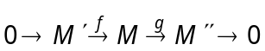 is a split exact sequence prove that 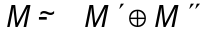.
(b) Prove that if 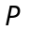 is a projective module, then there exists a free module 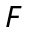 such that 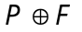 is free.
- (a) Show that the tensor product of two modules exists and it is unique upto isomorphism.
(b) Let  and  be free modules with bases 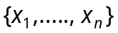 and 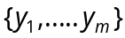, respectively. Then show that 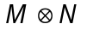 is free with basis 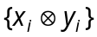.
- (a) Show that is faithfully flat if and only if is flat and for each maximal ideal m of R, mM M.
(b) State and prove Chinese Remainder theorem.
- (a) If 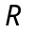 is an Artinian ring prove that the nil radical N(R) is nilpotent.
(b) Show that R_{s} is flate R-module.
- (a) Show that the nil radical of R extends to the nil radical of R_{s}.
(b) State and prove Hilbert’s basis theorem.
- (a) State and prove the structure theorem for artinian rings.
(b) State and prove Jordan Hölder theorem.
- (a) Prove that the ring of integers in an algebraic number field is Dedekind domain.
(b) Let R be a finitely generated k-algebra, k filed, and m a maximal ideal of R. Then prove that R/m is a finite extension of k.
- (a) Let R be a Noetherian domain in which every
non-zero prime ideal is maximal. Prove that the following statements are equivalent.
(i) R is Dedekind domain;
(ii) R_{p} is discrete valuation ring for every non-zero prime ideal, P of R;
(iii) Every primary ideal of R is a power of a prime ideal.
(b) Show that any R-module M can be embedded in an injective R-module.

————————
12
DE-2005
DISTANCE EDUCATION
M.Phil.(Mathematics) DEGREE EXAMINATION, MAY 2011.
MEASURE THEORY
(upto 2006 Batch)
Time : Three hours Maximum : 100 marks
Answer any FIVE questions.
(5 × 20 = 100)
Each question carries 20 marks.
- (a) Let 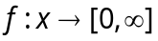 be measurable then there exists simple measurable function S_{n} on X then show that
(i) 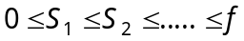
(ii) 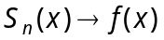 as for every 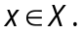
(b) Prove that the sums and products of measurable function into 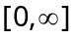 are measurable.
- State and prove monotone convergence theorem.
- Suppose and 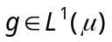 and 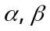 are complex numbers then prove that 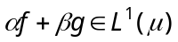 and 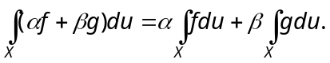
- (a) State and prove Holder's and minkowski's inequalities.
(b) If P and Q are conjugate exponents 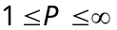 and if 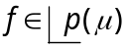 and 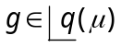 then prove that 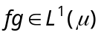 and 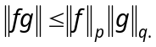
- Show that 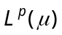 is a complete metric space for 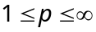 and for every positive measure .
- (a) If X is a locally compact Housdroff space then prove that 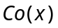 is the completion of 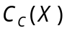 relative to the metric defined by the supremum norm 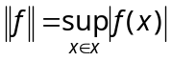.
(b) If 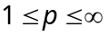 and 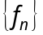 is a cauchy sequence in with limit f thene prove that has a subsequence which converges pointwise almost everywhere to 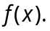
- State and prove Radon-Nikodyin theorem.
- (a) If 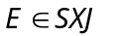 then prove that 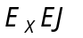 and 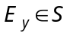 for every 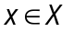 and 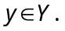
(b) State and prove Fubini theorem.
——————
13
DE-2006
DISTANCE EDUCATION
M.Phil. (Mathematics) DEGREE EXAMINATION, MAY 2011.
TOPOLOGICAL VECTOR SPACES
(Upto 2006 Batch)
Time : Three hours Maximum : 100 marks
Answer any FIVE questions.
All questions carry equal marks.
(5 × 20 = 100)
- If X is a topological vector space with a countable local base, prove that there is a metric d on X such that
(a) d is compatible with the topology of X
(b) the open balls centered at 0 are balanced, and
(c) d is invariant : 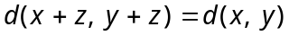 for 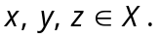
Further prove that if X is locally convex, then d can be chosen so that all open balls are convex.
- (a) Suppose A is a convex absorbing set in a vector space X. Prove the following :
(i) 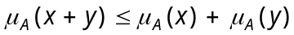
(ii) 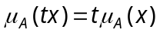 if 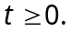
(iii) 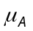 is a seminorm if A is bounded
(iv) If 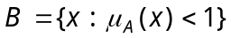 and 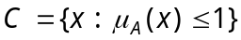 then 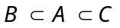 and 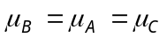.
(b) Suppose 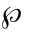 is a separating family of seminorm on a vector space X. Associate to each 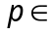 and each positive integer n, the set 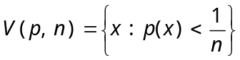. Let be the collection of all finite intersections of the sets 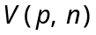. Prove that is a convex balanced local base for a topology on X, which turns X into a locally convex space such that
(i) every is continuous and
(ii) a set 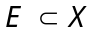 is balanced if and only if every is bounded on E.
- (a) State and prove the category theorem.
(b) State and prove open mapping theorem.
- (a) If X and Y are topological vector spaces, K is a compact convex set in 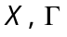 is a collection of continuous linear mappings of X into Y, and the orbits 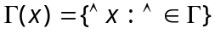 are bounded subsets of Y, for every 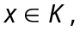 prove that there is a bounded set 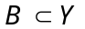 such that 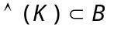 for every 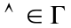.
(b) If f is a continuous linear functional on a subspace M of a locally convex space X, prove that there exists 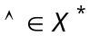 such that 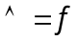 on M.
- (a) Suppose A and B are disjoint, nonempty, convex sets in a topological vector space X. Prove that the following :
(i) If A is open, there exists and 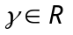 such that Re 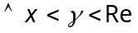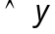 for every 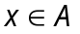 and for every 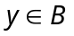
(ii) If  is compact, B is closed and X is locally convex then there exist 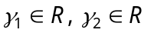 such that Re 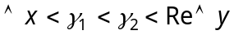 for every and for every .
(b) If X is a vector space and 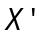 is a separating vector space of linear functionals on X, prove that -topology makes X into a locally convex space whose dual space is X'.
- (a) State and prove the Krein-Milman theorem.
(b) If X is a locally convex space and H is the convex hull of a totally bounded set prove that H is totally bounded.
- (a) If X and Y are normed spaces prove that
to each 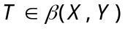 there corresponds a
unique 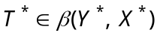 that satisfies 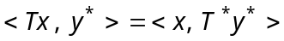 for all 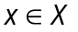 and 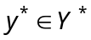. Also prove that 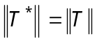.
(b) If X and Y are Banach spaces and if 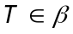 (X, Y) prove that the following equivalent
(i) 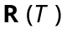 is closed in Y.
(ii) 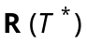 is weak*-closed in 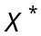.
(iii) is norm-closed in .
- (a) Suppose
(i) X is a Frechet space.
(ii) Y is a complemented subspace of X.
(iii) G is a compact group which acts as a group of continuous linear operators on X.
(iv) 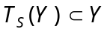 for every 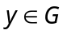.
Prove that there is a continuous projection Q of X onto Y which commutes with every 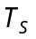.
(b) If P is a continuous projection in a topological vector space prove that 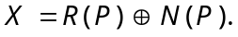 Conversely, if X is an F-space and if 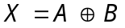 prove that the projection P with range A and null space B is continuous.

————————
DE–2007
14 (a)
DISTANCE EDUCATION
M.Phil. (Mathematics) DEGREE EXAMINATION, MAY 2011.
FUNDAMENTALS OF DOMINATIONS IN GRAPH
(Upto 2006 onwards)
Time : Three hours Maximum : 100 marks
Answer any FIVE questions.
All questions carry equal marks.
(5 × 20 = 100)
- (a) State and prove ORE theorem.
(b) Show that a graph G is bipartite if and only if it has no odd cycle and that the chromatic number of a bipartite graph is 2.
- (a) Show that for a graph G with even order and no isolated vertices, 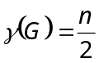 if and only if the components of G are the cycles 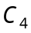 or the corona 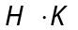, for any connected graph H.
(b) State and prove Nieminen theorem.
- Show that a connected graph G satisfies 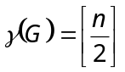 if 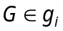 for some 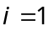 to 4.
- (a) Show that if a graph G has no isolated vertices then 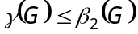.
(b) Show that for any graph G,
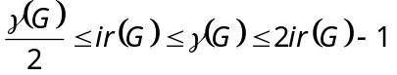.
- (a) Show that for any strongly perfect graph G,
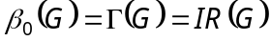
(b) Show that for any graph G, 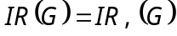.
- Show that if T is a tree of order 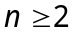 then
(a) 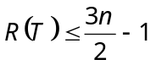
(b) 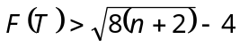.
- Show that the k-cube 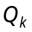 has a perfect d-cube if and only if
(a) 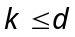
(b) 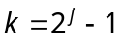 and 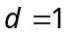
(c) 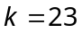 and 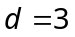.
- State and prove the necessary and sufficient conditions for a graph G to be a member of UER.
————————
DE–2008
14 B
DISTANCE EDUCATION
M.Phil. (Mathematics) DEGREE EXAMINATION, MAY 2011.
DATA STRUCTURES AND ALGORITHM
(upto 2006 Batch)
Time : Three hours Maximum : 100 marks
Answer any FIVE questions.
All questions carry equal marks.
(5 × 20 = 100)
- (a) Write notes on classes and objects. (10)
(b) Write a program that over loads ++ and – – operators. (10)
- (a) Explain the concept of polymorphism. (10)
(b) Explain the class declaration of arrays. Describe the implementation of such arrays with examples. (10)
- (a) Extend the class polynomial for performing addition, subtraction and division of polynomials using overloaded operators. (10)
(b) What is the use of head nodes in the linked lists?
(10)
- (a) Explain implementation of stacks using arrays. (10)
(b) Write a recursive algorithm for finding factorial of a number. Convert this into a non recursive form using stack. (10)
- (a) Explain circular queue with an example. (10)
(b) Explain the operations on queues with example. (10)
- (a) Discuss binary tress. (10)
(b) Write a non recursive algorithm for post-order traversal on a binary tree. (10)
- (a) Explain binary search tress. (10)
(b) Write an example which takes a binary tree and swaps the left and right children of every node. Find the computation time of your algorithm. (10)
- (a) Explain Kruskal’s algorithm. (10)
(b) Write a procedure to determine whether or not G is an undirected graph. (10)
—————

